29th International Confederation of Midwives Congress
Durban 2011

Save the Children’s EVERY ONE Midwife Award
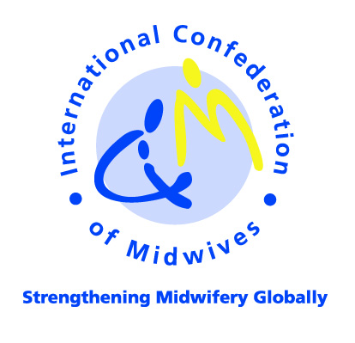

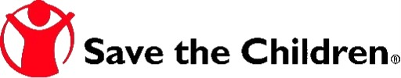

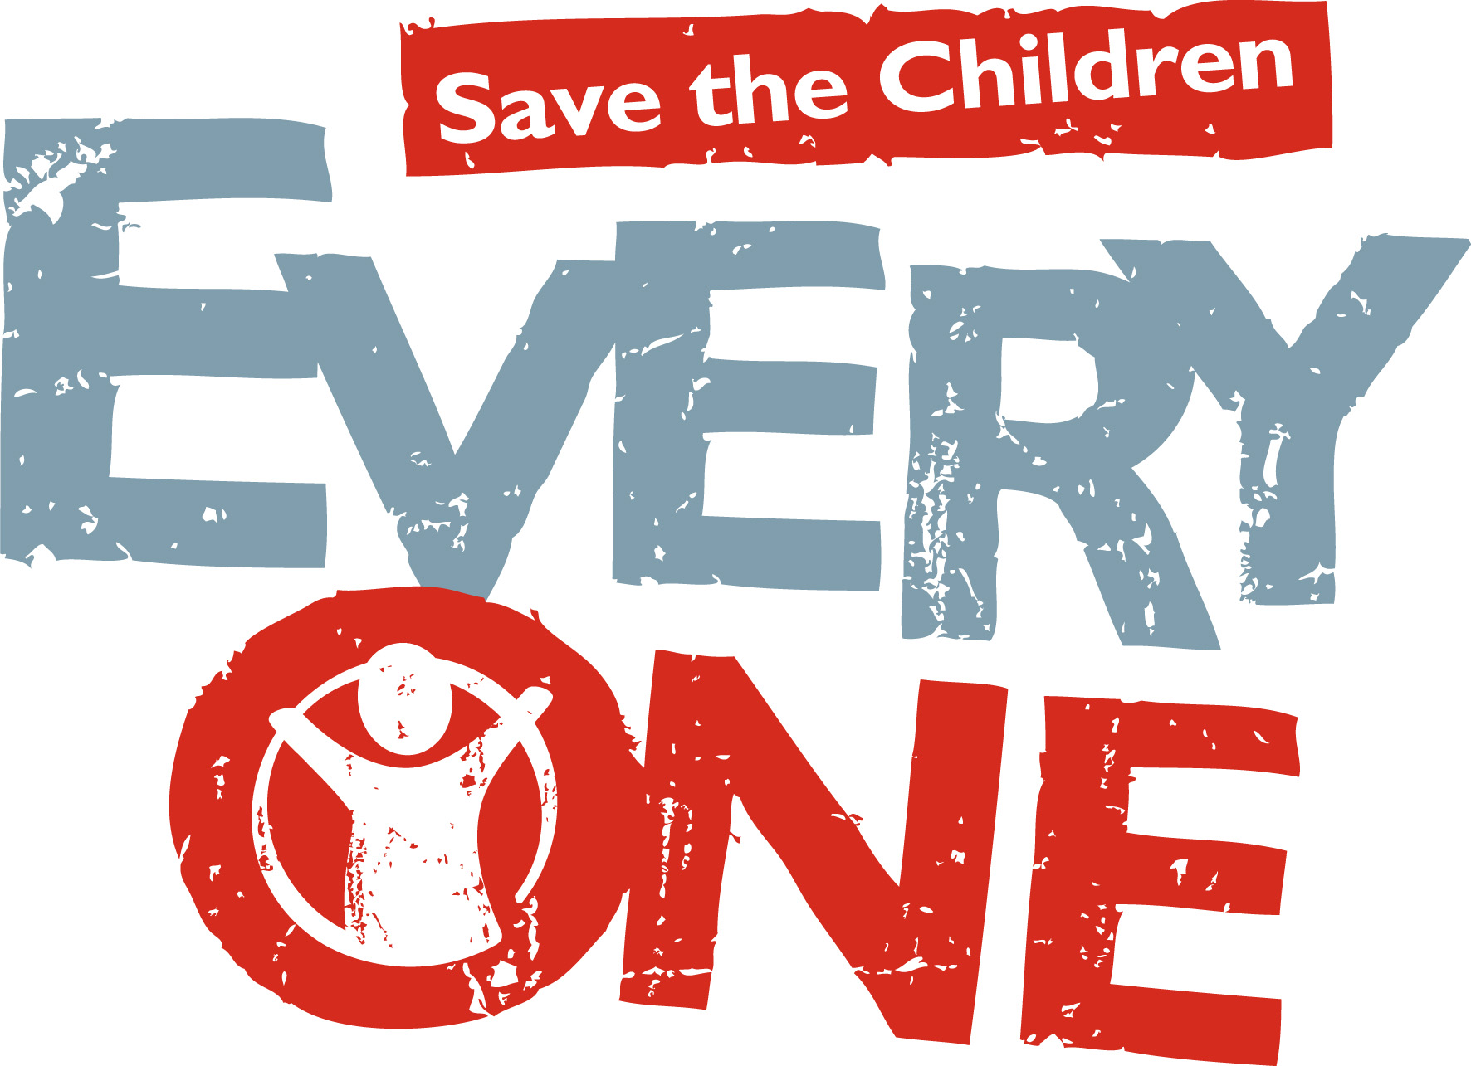
SAVE THE CHILDREN’S EVERY ONE MIDWIFE AWARD
Background
Birth is the time when the risk of death is greatest. Globally almost one million unnecessary neonatal deaths occur at the time of birth each year, as well as an additional one million intrapartum stillbirths and 350,000 maternal deaths. All these deaths occur just when new life is expected – a total of over 2 million birth-related deaths globally each year, mostly in low income countries. Reducing these deaths is crucial to meeting the Millennium Development Goals (MDGs) for child survival (MDG 4) and maternal health (MDG 5). Many countries could accelerate MDG progress with more investment on care at birth. More midwives as well as essential equipment and skills are critical.

The International Confederation of Midwives (ICM) and the Society of Midwives of South Africa (SOMSA) are pleased to be hosting the ICM 29th Triennial Congress in Durban, South Africa in 19-23 June 2011 (http://www.midwives2011.org/).The theme of the Congress, Midwives Tackling the Big Five Globally, addresses the five leading causes of maternal death and morbidity in low-resource settings. Many of these causes are directly linked to newborn deaths and to stillbirths. By examining the health of women and their babies, this Congress provides an opportunity for midwives to make a major contribution to achieving MDGs 4 and 5, ensuring the well being of the world’s mothers and their newborns.

There is a shortage of midwives internationally and particularly in Africa. Midwives provide the majority of immediate care to newborns born in facilities, often despite a lack of specific support or training for newborn care. Too often midwives work hard, against the odds and receive little recognition. ICM together with Save the Children would like to identify and reward two midwives who have been champions for newborn survival. This is the third occasion that Save the Children has made this global award. The first winner was from Ethiopia and the second winners were from Malawi and South Africa – these exceptional women promoted change at scale against the odds.

This year the awards will be given on behalf of EVERY ONE, Save the Children’s global campaign to save children’s lives, and Save the Children’s Saving Newborn Lives program (SNL), supported by the Bill & Melinda Gates Foundation. Save the Children tackles the most common causes of newborn and child deaths and is building a movement in over sixty countries to support action to save children’s lives and urge leaders to live up to their promises to children. To stop needless deaths of newborn babies and children and achieve the fourth Millennium Development Goal, Save the Children recognizes that there needs to be a health worker within reach of every vulnerable child, who is trained, equipped and supported to deal successfully with the principal threats to that child’s survival through the first five years of life.

Nomination and selection process
A nominator must submit the form below along with a description justifying the nominee’s achievements in newborn care by 4th April 2011. The nominations will be reviewed by a panel and winners will be notified by in May 2011. The winner will have their travel and expenses paid to attend the Congress and will be presented with their award during the opening ceremonies. Runners-up will be identified and acknowledged.

SAVE THE CHILDREN’S EVERY ONE MIDWIFE AWARD
TERMS OF REFERENCE
Purpose: To bestow an award on midwives who have demonstrated their achievements as change agents in improving basic newborn health care practices through training, and/or provision of services, and/or advocacy in a low- or middle-income country that is high burden for maternal and neonatal deaths.

Award: Awards will be given to two midwives from low- or middle-income countries with the highest burden for maternal and newborn deaths (see Annex 1) who have significantly contributed to care for the newborn. The Awards will be given in 2011 at the 29th ICM Triennial Congress.
The Awards comprise of a trophy and certificate of recognition. It also includes round trip travel, accommodation, meals and registration fee for the 29th Triennial Congress in Durban, South Africa. Media attention is expected in South Africa and in the recipient’s country.

Selection process: A call for nominations will be sent by ICM to midwifery associations and by Save the Children International to national Save the Children organisations. Nominations can completed online (http://www.healthynewbornnetwork.org/page/save-childrens-every-one-midwife-award) or applications can be sent to savingnewbornlives@savechildren.org

Selection criteria: Award winners will be selected based on the effectiveness and potential impact and sustainability of their interventions in the community. A nominee should-
- Be working in a low- or middle-income country that is high burden for maternal and neonatal deaths (see annex 1 data);
- Be actively working in the public or non-profit health sector, in clinical work, education, research or outreach, having an effect beyond one hospital or unit;
- Provide an example of commitment to newborn care for example in training in essential newborn care, resuscitation, kangaroo mother care;
- Show compassion and empathy for women, newborns, families, as well as co-workers;
- Be a positive role model - dynamic, motivated, passionate, an agent for change;
- Remain up to date with current midwifery practice;
- Promote and participate in building a positive work environment, including staff growth, mentorship, learning and development.

Selection Committee: A representative from the Board of the International Confederation of Midwives, together with a representative of Saving Newborn Lives/Save the Children and a representative of Save the Children’s EVERY ONE Campaign.

Award process: Announcement is made at the 2011 Council meeting. The award ceremony will take place during the Opening Ceremony of the 29th Triennial Congress in Durban, South Africa.

Award announcement: Award events will be covered in the ICM journal International Journal of Childbirth and forwarded to all ICM partners, midwifery journals and other appropriate media.

Report: Within six months, the recipients will each submit a report on attention for midwives and newborn care in their country as a result of their award.

ANNEX 1 – The 20 countries with the highest numbers of maternal and newborn deaths
- Afghanistan
- Angola
- Bangladesh
- Burkina Faso
- Cameroon
- Cote d'Ivoire
- Democratic Republic of the Congo
- Ethiopia
- India
- Indonesia
- Kenya
- Mali
- Mozambique
- Myanmar
- Niger
- Nigeria
- Pakistan
- Sudan
- Uganda
- United Republic of Tanzania

Country selection: The State of the World’s Midwife Report includes 61 countries based on the UN Secretary General’s plan for Women and Children, Countdown to 2015 etc. If these 61 countries are ranked by the combined number of maternal and neonatal deaths, then the top 20 countries together account for 66.3% of the world’s maternal and neonatal deaths. The top 15 countries account for 62.4% of the world’s maternal and neonatal deaths. This list gives the top 20 countries

SAVE THE CHILDREN’S EVERY ONE MIDWIFE AWARD

NOMINEE SUBMISSION FORM

Birth is the time when the risk of death is greatest resulting in a total of over 2 million birth-related deaths globally each year, mostly in low income countries. Midwives provide the majority of immediate care to newborns born in facilities, often despite a lack of specific support or training for newborn care. Too often midwives work hard, against the odds and receive little recognition. ICM together with EVERY ONE, Save the Children’s global campaign to save children’s lives, and Save the Children’s Saving Newborn Lives program, supported by the Bill & Melinda Gates Foundation would like to identify and reward two midwives who have been champions for newborn survival.

A nominator must submit the form below along with a description justifying the nominee’s achievements in newborn care by 4th April 2011. The nominations will be reviewed by a panel and winners will be notified by May 2011. The winner will have their travel and expenses paid to attend the Congress and will be presented with their award during the opening ceremonies. Runners-up will be identified and acknowledged.

Selection Criteria:
A nominee should-
- Be working in a low- or middle-income country that is high burden for maternal and neonatal deaths (see annex 1 for a list of qualifying countries);
- Be actively working in the public or non-profit health sector, in clinical work, education, research or outreach, having an effect beyond one hospital or unit
- Provide an example of commitment to newborn care for example in training in essential newborn care, resuscitation, kangaroo mother care;
- Show compassion and empathy for women, newborns, families, as well as co-workers;
- Be a positive role model - dynamic, motivated, passionate, an agent for change;
- Remain up to date with current midwifery practice;
- Promote and participate in building a positive work environment, including staff growth, mentorship, learning and development.

Application instructions:
- The application must be accompanied by a brief description of nominee’s career history and describe why this person should win the award considering the selection criteria above and provide specific examples of how the nominee has demonstrated commitment to midwifery, including examples of the nominee’s leadership qualities and impact for newborn care.

- Fill out the form at http://www.healthynewbornnetwork.org/page/save-childrens-every-one-midwife-award or print the application form below and submit by email: savingnewbornlives@savechildren.org. All nominations must be submitted by 4th April 2011.

Application form - Closing date for submission of nominations: 4th April 2011

Country ____
Nominee Information:
Name ____
Place of work (government, not-for-profit, private sector): ____
Qualifications ____
Job Title
Address
Country__________________________
Phone
Fax
Email

Nominator Information:
Name ____
Name of Association ____
Qualifications ____
Job Title
Address
Country__________________________
Phone
Fax
Email

Give brief description of nominee’s career history and describe why this person should win the award considering the selection criteria above and provide specific examples of how the nominee has demonstrated commitment to midwifery, including examples of the nominee’s leadership qualities and impact for newborn care (1500 word maximum):

.

Afghanistan, Angola, Bangladesh, Burkina Faso, Cameroon, Cote d'Ivoire, Democratic Republic of the Congo, Ethiopia, India, Indonesia, Kenya, Mali, Mozambique, Myanmar, Niger, Nigeria, Pakistan, Sudan, Uganda, United Republic of Tanzania

