Early Communication Intervention
with babies in
Kangaroo Mother Care


A programme to be used with mothers and their preterm infants
in kangaroo care

Preterm and low birth weight babies need very special care to keep them healthy and to help them grow well
- The best you can do for your low birth weight and preterm baby is to do kangaroo mother care as much as possible during the day and night

- You also need to give your baby breast milk, either by breast feeding or giving your own pasteurized breast milk or pasteurized donor breast milk

- There are a number of other things you can do to help your baby’s development (growth) while you are doing kangaroo mother care:
- Your baby must learn to recognize your voice against all the other background noises in the nursery. Your baby must learn to listen to your voice, because you are the most important person to teach your baby language. Talking will help your baby do well at school one day..
- The brains of preterm babies are growing and changing very fast. That is why babies must be protected against bad stimulation like loud noise, bright lights and bad touch. Babies must always be left to sleep undisturbed except when you wake them for feeding
- You can learn to know when your baby is ready for stimulation and when your baby is stressed and tired. We will teach and show you what the signs are when your baby is stressed and tired and what to do about it.
- You can learn about your baby’s 3 stages of development and use the right kind of stimulation at the right time
- Find out the developmental stage of your baby, by adding your baby’s age in weeks to his/her gestation age. Sick babies may stay in the in-turned stage for a long while.
Stage 1: In-turned stage

Babies born before 32 weeks, are in an in-turned stage. They are not yet ready for interaction
- They respond to sounds and voices in subtle (delicate) ways
- They sleep most of the time
- They keep their eyes closed
- They open their eyes only for a moment
- They make very few movements

What you can do when your baby is in the in-turned stage:
- Keep your baby in kangaroo mother care as much as possible. You may move around when you are doing kangaroo mother care.
- Feed your baby regularly and watch the weight gain
- Allow your baby to sleep for long periods
- Talk and sing softly to your baby, close to his/her ear. This way you are teaching your baby to recognize your voice
- It is best not to play music to your baby at this stage
- Stop your interaction with the baby when you see stress signs

Stage 2: Coming-out stage

Babies born at 32 to 34 weeks, are in the coming-out stage. They are almost ready for interaction.

- They sometimes open their eyes
- They sometimes move or make soft noises
- They may put their hands on their faces
- They may bring their hands to their mouths
- They may hold onto something, like your finger

What you can do when your baby is in the coming-out stage:
- Keep your baby in kangaroo mother care as much as possible. You may walk around while doing kangaroo mother care.
- Feed your baby regularly and watch the weight gained
- Allow time for sleeping, but also some time for interaction
- Position your baby so that you can make eye contact
- Talk to you baby when he or she is awake. This way your baby learns to listen to your voice
- Watch out for stress signs and stop your dealings. This way you will make sure that (sentence not completed)
Stage 3: Reciprocity stage

Babies born at 36 weeks or later are in the reciprocity stage, they are ready for interaction
- Your baby can now look at you for a longer period of time, or look at a specific object
- Your baby will also start to look around
- Your baby will move the arms and legs
- Make soft sounds
- Bring the hands to the mouth, suck them or put the one hand over the other
- Holds onto your finger or a rattle
- Start to suck if you give your little finger or offer the breast

What you can do when your baby is in the reciprocity stage:
- Keep your baby in kangaroo mother care as much as possible. You may and should move and walk around with your baby in the skin-to-skin position.
- Feed your baby regularly and monitor the weight gain
- Let your baby look at objects. Using a mobile with black and white patterns is one good idea. After a while your baby can look at a mobile in soft colours.
- Position your baby so that you can look into his/her eyes. Try to keep eye contact for longer periods than in Stage 2.
- Babies like to look at faces, so make sure that you often look at your baby
- Talk and sing often to your baby. Tell him/her that you love them, talk about your family, about home, about anything that comes into your mind. Your baby needs to get used to your talking. Change the tone of your voice to make your voice sounds interesting, talk in short sentences, use natural pauses. You want to keep your baby’s focus with your voice.
- Look at your baby’s face and see how he/she will move their lips and stretch their eyebrows after you talked to them. Babies do these facial movements when they hear your talking. They respond to your talking by giving you very subtle (delicate) signs that they are beginning to learn language.
- Listen to your baby’s sounds and imitate them. If you imitate your baby’s sounds, he/she will learn to imitate your sounds. These are the first steps to talking, your baby’s key to education and quality of life.
- It is important that you continue to talk to your baby as he/she grows older. Talk to your baby in your first language and introduce a second language when your child can communicate in his/her first language already.
Stress signs which indicate that your baby should be left to rest for a while:
- Your baby looks away or closes the eyes  - Baby shows a stop sign with the hands | - Pushes the feet and arms out  - Stretches out the arms
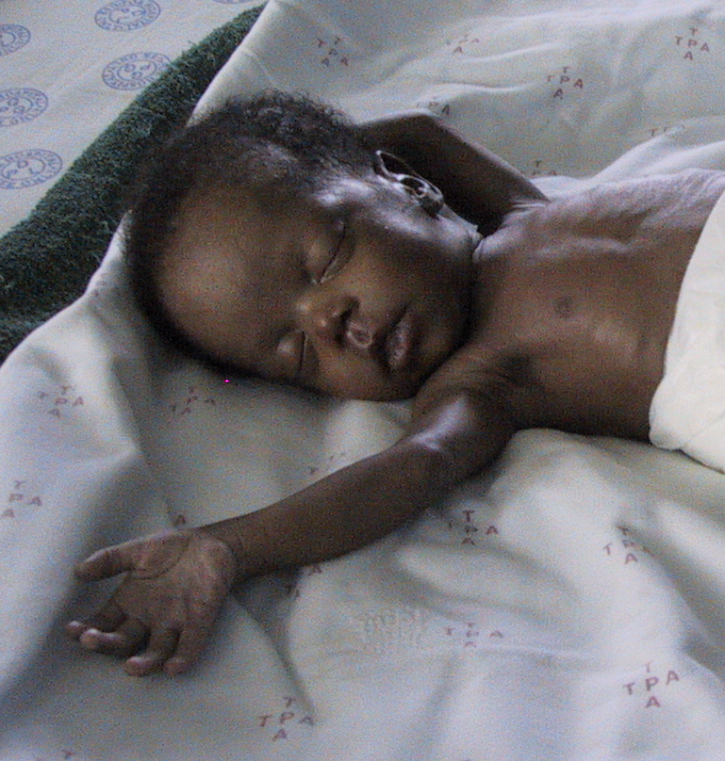 | 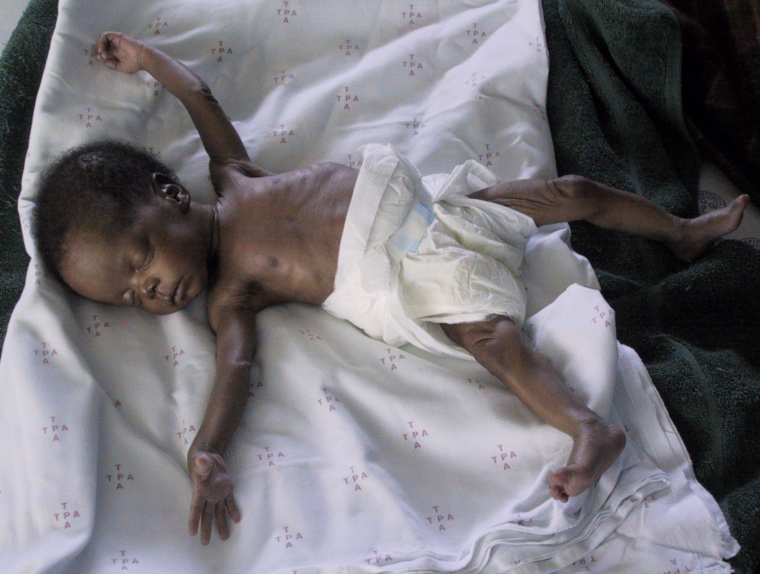
- Covers the eyes or face with the arms  - Hiccups, sneezes, coughs, cries or yawns | 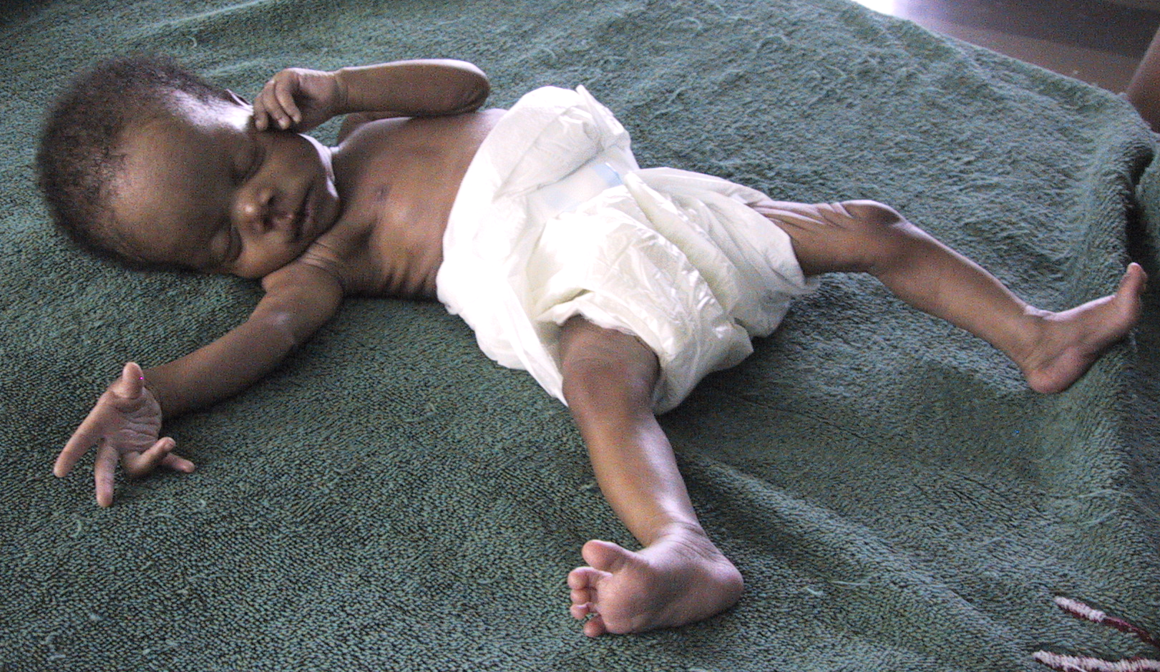

What you can do to reduce your baby’s stress:

- Put your baby back in the kangaroo position
- Take your baby to a quiet room or switch off the radio or TV
- Dim the lights or walk away from bright lights
- Hold your baby securely against your chest. It is best not to pat or rock your baby now.
- Talk softly to your baby, but do not try to make eye contact now. If your baby knows your voice, he/she will be calmed.
If you are concerned about your baby’s feeding, hearing or communication abilities, contact your nearest clinic for
- A referral to a speech-language therapist, who can help with feeding difficulties and give your further guidelines on how to stimulate your baby’s communication development, or a
- A referral to a paediatric audiologist, who can test your baby’s hearing.
It is never too early for intervention

Compiled by Prof Alta Kritzinger (2008)

Clinic for High Risk Babies (CHRIB)
Department of Communication Pathology, University of Pretoria

Based on a research project:
The effectiveness of an early communication intervention programme
on mothers in kangaroo care (Kritzinger, A., van Rooyen, E., & Owen, R.)

It is recommended that the pamphlet is given to mothers, but supported by explanations and discussion by the health care provider or therapist

Enquiries: alta.kritzinger@up.ac.za

