Introducing malaria intermittent presumptive Treatment for pregnant women in the Sikasso Region, Mali:

Test of two service delivery approaches

National Malaria Prevention Program in Mali

Collaborators
Reproductive Health Division
Sikasso Regional Health Direction
Bougouni, Kolondièba, and Yanfolila Health Center Teams

Malaria Research and Training Center

Save the Children USA/Sahel Field Office
Saving Newborn Lives/Mali.

May 2005

TABLE OF CONTENTS

1. INTRODUCTION………………..……………………………………………1

2. STUDY AREA …………………………………………………………………2

3. MATRIAL and METHOD ……………………………………………………3

4. RESULTS ………………………………………………………………………4

4.1. Demogratic characteristics of women interviewed …………………..6

4. 2. Study results …………………………………………………………..7

4.3. Births out comes……………………………………………………….8

4.4. Knowledge and women opinions on Malaria ………………………..9

4.5. Used of malaria prevention medicines ...……………………………10

4.6. Bed net ………………………………………………………………..15

4.7. Health cares providers and village drug kits managers ………..……..17

5. DISCUSSION AND CONCLUSION ……………………………….………..22

6. GENERAL CONCLUSION …………………………………………………..23

7. BIOLOGICAL FINDINGS…………………………………………………….24

8. COST EFFECTIVENESS FINDINGS

LIST OF ACCRONYMS

ANC Antenatal care

BCC Behavior change communication

CHC Community Health Center

CHW Community Health Worker

CPM Chef de Poste Medicaux (Community health center officer)

CVS Village Health Committee

DEAP Divison Epidemiologie Entomologie et Parasitologie (Division of Epidemiology and Parasitology
DHS Demography Health Survey
DOT Direct observed treatment

DSR Direction Santé de la Reproduction (Reproductive Health Direction)

FMPOS Faculté de Medecine de Pharmacie et Odontostomatologie (University of Bamako Faculty of Medicine, Pharmacy and Dentistry)

PNLP Programme National de Lutte contre le Paludisme (National Malaria Control Program)

SNL Saving Newborn Lives

SP Sulfadoxine pyrimethamine

TBA Traditional Birth Attendant

1. Introduction
- Malaria in Mali
According to Ministry of Health data (DEAP/FMPOS), malaria is the leading cause of mortality (13.0%) and of morbidity (15.6%) among the general population in Mali. Between 80 and 90% of children carry plasmodium parasites in their blood during the rainy season. Malaria is the leading cause (1 out of every 2 cases) of febrile convulsions among children admitted to the pediatric service of Gabriel Touré Hospital in Bamako, and the second cause of fever in the internal medicine service of the Point G Hospital in Bamako. It is estimated that P. falciparum, the most dangerous of the malaria parasites, is responsible for approximately 90% of the cases and almost all complicated cases, followed by P. malariae which is responsible for approximately 10% of the cases. Considerable research has been carried out on patterns of antimalarial drug resistance in Mali ^{1, 2, 3}, primarily through the malaria research center at the University of Mali funded by the National Institutes of Health. Significant chloroquine resistance is present in Mali, Ministry of Health did adopted a new policy with the introducing of Arthesunate combination treatment
The principal malaria vectors in Mali are Anopheles gambiae s.l., including Anopheles gambiae sensu strictu and Anopheles arabiensis, and Anopheles funestus. Five patterns of malaria transmission have been defined in Mali. The southern end of the study area is typical of the zone with a long period of seasonal transmission, lasting 4 to 6 months. Towards the northern end of the project area rainfall is less and the transmission season may last closer to 3 to 4 months. Figure 1 presents the varying malaria transmission patterns in Mali.

There are several recently published articles on malaria research carried out in Sikasso Region that confirm that malaria is a major public health problem. In a study in the District (Cercle) of Yanfolila at the end of the rainy season in 1998, of 399 mothers interviewed, 131 had sick children ⁴. Of the 131 sick children, 58 had a febrile illness (soumaya), and 57 were parasitically with parasite densities from 80 to 213,600 parasites per μl ⁴. 88.9% had P. falciparum, 4.2% P. malariae and 6.9% had a mixed infection of the two parasites ⁴. This probably underestimates the level of parasitemia among sick children, as 33 of the 58 children with a febrile illness (soumaya) had already been treated with an antimalarial. A study in Bougoula village, Kolondièba District, demonstrated malaria in pregnancy has an important negative impact on birth weight in first and second pregnancies (CITE - Bouvier), and also demonstrated that malaria is a major cause of anemia in pregnancy in Sikasso Region (CITE - Bouvier). A strong seasonal pattern of anemia among women of lower parity was found (dry season = 8.7%, rainy season = 41.2%), which was suppressed in a subsequent phase of the study when women were given malaria chemoprophylaxis 6.
- Malaria Transmission, Mali

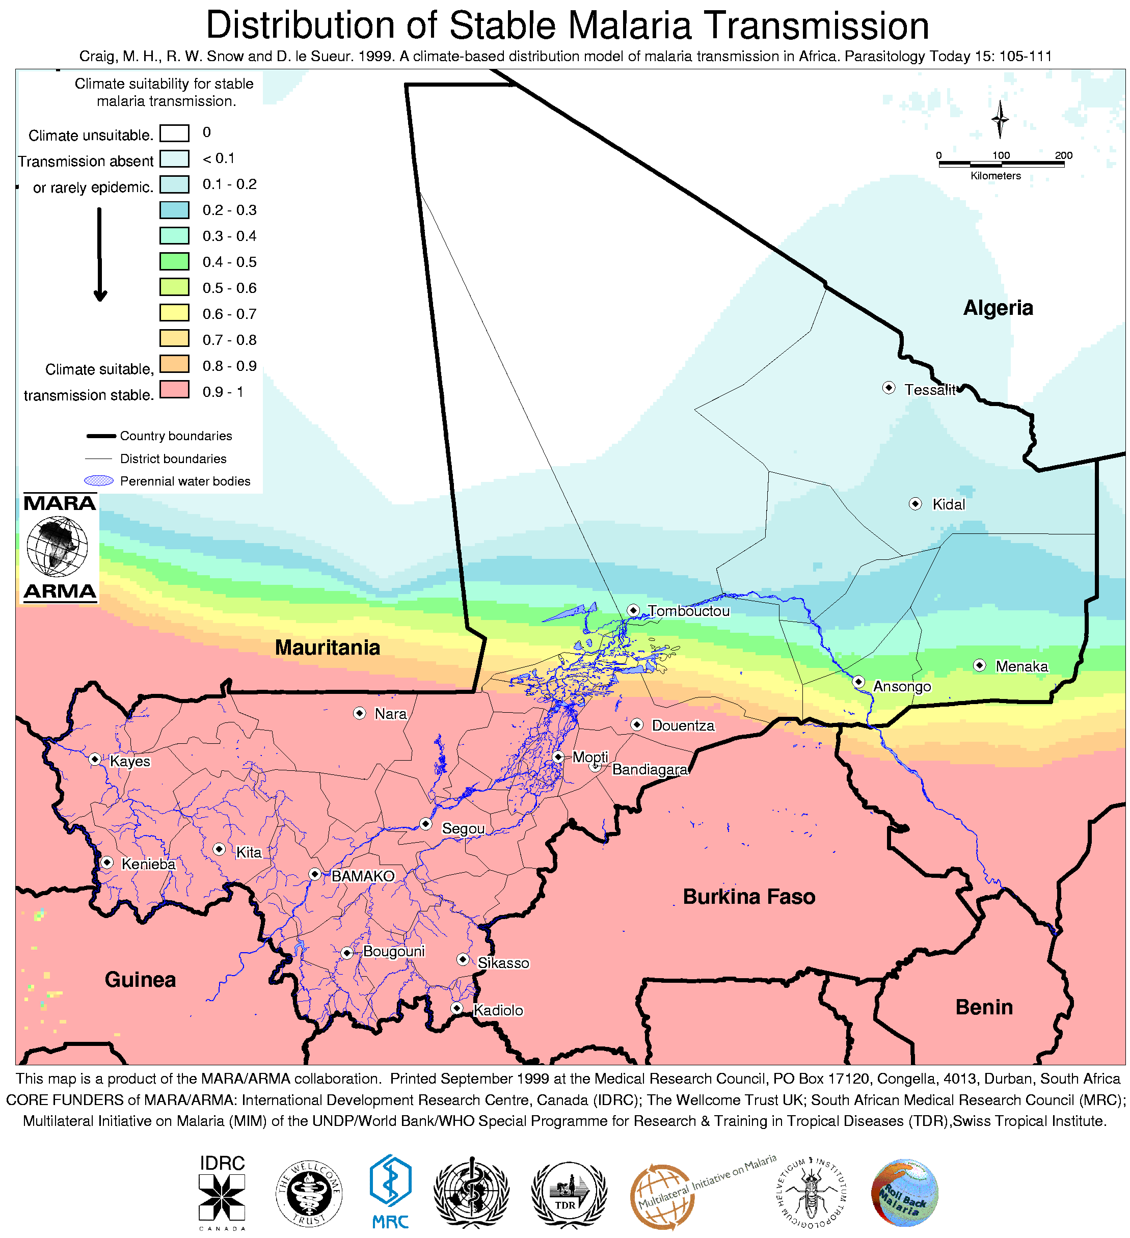
- Malaria & pregnancy
Prevention and control of malaria infection among pregnant women is one of the key components of the PNLP roll back malaria strategy. Like most of the sub Saharian Africa countries, malaria is endemic in Mali. Low birth weight (LBW) is the third leading cause to neonatal deaths. Reducing the percent of low birth weight will reduce neonatal mortality rate. An estimate shows malaria infection in pregnancy as a cause of about 35% of preventable LBW in Africa (Stewekete et al. 1996)

- Policies concerning malaria in pregnancy in Mali
The Malian government has adopted the Roll Back Malaria Initiative. A goal of this initiative for 2005 is to protect 60% of pregnant women against malaria by the use of a intermittent presumptive treatment (IPT) strategy and through the use of insecticide-treated bed nets (ITNs). After careful deliberations, the Malaria Prevention and Control Program Mangers of six countries agreed that the administration of two doses of sulfadoxine Pyrimethamin between four and eight months would be the best strategy to protect pregnant women against Malaria.
The IPT introduction was one of the goals of SNL /Mali Program in Bougouni. Kolondieba district had been chosen because it is one of Save the Children health program impact areas.
- Study Rationale
The current Malaria prevent and control among pregnant women policy is based on weekly chloroquine dose of 300mg of chloroquine during pregnancy and two months after delivery, The compliance for this regimen is very low.The PNLP and DSR Directors were convinced that IPT using two doses of SP aws the best way of reducing the malaria effects on pregnancy.To determine the most effective and cost effective strategy to deliver IPT services, the DSR and Save the Children through SNL/Mali, the Malian PNLP decided to test two strategies of IPT delivery:
Strategy 1: Provide IPT services through antenatal care at health care centers and outreach activities to expectant mothers
Strategy 2: Provide IPT services through antenatal care at health care centers, outreach activities and village drug kits to expectant mothers
The PNLP will adopt recommendations for national IPT policy pending the study findings.

2. Study Areas
The study was carried out in the Bougouni, Yanfolila, and Kolondieba districts, in the Sikasso region located in southern Mali. The study areas are highlighted in figure 2, Mali is a land-locked West African country with a surface area of 1,241,238 km². Mali is one of the poorest countries of the World and ranked 153 out of 162 countries in the 2001 Human Development Index prepared by the United Nations Development Program (UNDP). According to the 2001 DHS survey (EDS-III), the literacy rate is 14.8%, the Total Fertility Rate (15-49) is 6.8, the Neonatal Mortality Rate (before five years) is 57.1 per 1000 live births, the Infant Mortality Rate is 113.4, the Child Mortality Rate is 130.5 and the Under-Five Mortality Rate is 229.1.
The Sikasso Region is the part of the country with the greatest annual rainfall and longest rainy season, and consequently accounts for a substantial proportion of the national mortality and morbidity attributable to malaria. The Bougouni district has 25 health zones, Yanfolila has 17 and the Kolondieba district has 16 health zones, each one consisting of one community health center (CHC) and the villages in its catchment area. A head nurse, rural midwives (matrones), a nurse’s assistant and a drug sales manager staff each community health center. The rural midwife is responsible for antenatal cares in the Community Health Center, although the CPM may see pregnant women. In these areas, each health zone, in addition to one health centre, has six to twelve village drug kits, which provide treatment in the community for common ailments. These village drug kits are supported by Save the Children and the US Centers for Disease Control, in cooperation with the Ministry of Health in health zones where Save the Children works in Sikasso Region.

The village drug kits were established because, at the beginning of the USAID-funded Child Survival XI project in Bougouni District, it was noted that basic drugs and other products were not available at the village level that were necessary for the project to achieve its objectives. This was most noticeable for malaria, as chloroquine was completely unavailable in many villages. Village drug kits were instituted in most of the villages with a functioning Village Health Committee (CVS). Villagers had to pay for all products, although some allowance was made for drugs to be purchased on credit, particularly malaria drugs during the rainy season. In addition to capitalizing the initial ‘drug kits’, Save the Children provides 35-day literacy training to the manager of the village drug kit, equivalent to community health worker (CHW) or community-based distributor in other contexts. The managers are also trained in the prescription of the medicines in their kits, as well as the pricing of them so as to ensure sufficient cost recovery for ongoing sustainability. Periodic supervision by Save the Children staff and health center personnel is carried out to ensure that the village drug kits are being managed appropriately. Save the Children has established 391 drug kits in villages (with individual populations of about 1,000) in the three district of Bougouni ,Kolondieba and Yanfolila since 1997. Stocked with only seven items: Aureomycin 1% eye ointment, Paracetamol, ORT, alcohol, bandages, chloroquine tablets and syrup, these drug kits enable people to have immediate access to treat their most common health problems, including malaria. Without the village drug kits, many people either have to walk up to fifteen kilometers to a Health Center or rely on traditional herbal treatments.
- Map of Mali and study sites

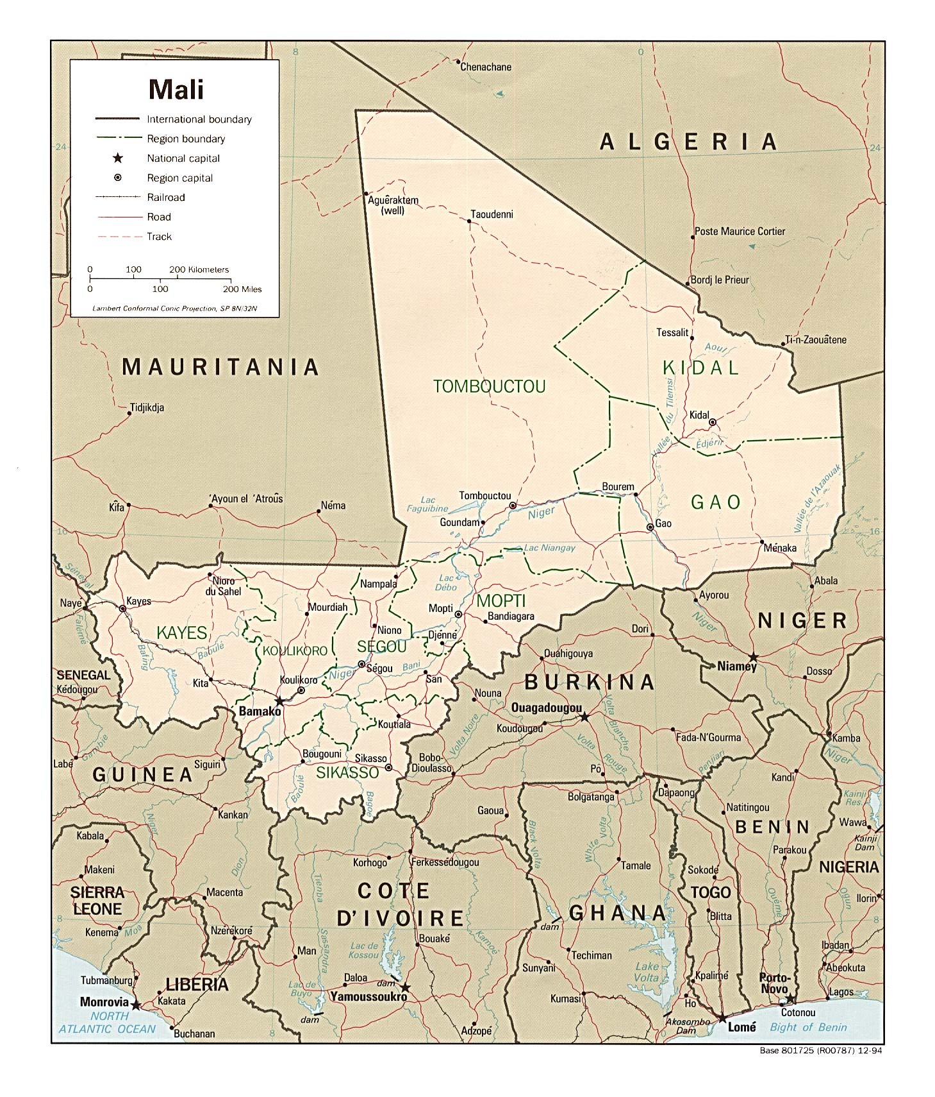

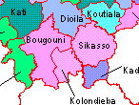

3. Methods

Overall Study Design
Two different, yet comprehensive intervention packages targeting intermittent presumptive malaria treatment for pregnant women were introduced in two health districts in southern Mali. The delivery strategies in each intervention arm were:
- Intervention Arm 1 - consisted of selling SP to pregnant women at the health centers level
- Intervention Arm 2 - consisted of selling SP to pregnant women at the health centers level and at village drug kit (community) level.

Bougouni was chosen as the site for implementation of intervention arm 1 which consisted of the community health center level only, while Koliendiaba district was chosen for intervention arm 2 which included both facility and community approaches. Both of the approaches were supported by intensive Behavior Change Communication activities.
The process of introducing the intervention strategies and their impacts were evaluated using a KPC survey and biological examine of women who gave birth within two months

Intervention
The intervention package consisted of 1) training all the health care providers involved, 2) supervision of the intervention implementation, 3) Assuring a drug supply, 4) communication activities to sensitize the target population, and 5) monitoring of intervention progress. These components are described in more depth below.

1. Training: Before the introducing the prescription of SP for pregnant women, serial training sessions were organized for health care providers who were involved at the two referral hospitals in Bougouni and Kolondieba, for all the health personnel working in the community health centers (CPM and rural midwives). These trainings were conducted by a team from the national malaria control program (PNLP). In the Kolondieba district all the village drug kit managers and TBAs from the villages with a drug kit were trained by the community health center personnel. All trainings covered the importance of the correct dosing of SP, the determination of duration of the pregnancy, and the importance of directly observing treatment. Training topics also included counseling and BBC activities.

2. Supervision: Three kinds of supervision were implemented during study period. Firstly, supervision was conducted every two months by a national team of four people from the Malaria Control Program (PNLP), Ministry of Health (National Division of Health (DNS)) and Malaria Research and Training Centre (MRTC). The goal of these supervisory visits was to a) assure correct SP administration to pregnant women with respect to DOT, b) verify correct determination of the duration of pregnancy, c) assure the quality of data collection at sentinel sites, and d) ensure the quality of laboratory tests. During each supervisory visit, at least 4 CSComs were randomly chosen to be included. Locally, a team from the Kolondieba referral hospital supervised each of the 16 community health centers twice during a period of 6 months. Finally, community health center staff supervised 75 villages drug kit managers and TBAs on a monthly basis. The local supervision at the community health centers and villages levels had the same goals and objectives as the national supervision team.
3. Drug Supply: Save The Children, USA provided the SP to sell at all levels as recommended by the Malian national policy. The community health centers and villages drug kits were given an initial supply of SP that was estimated to last two years.
4. Communication/Sensitization: To support the introduction of SP treatment for pregnant women in both Bougouni and Kolondieba district, a great sensitization campaign was conducted. Training was conducted for 15 radio broadcasters in order to initiate related radio broadcasts. Counseling cards were developed and were distributed at all community health centers and villages with drug kits level. Posters were displayed at all community health centers and in villages with drug kits.
5. Monitoring: Monitoring tools were developed which included notebooks used to collect pertinent information at the village drug kit level and health facility registers utilized in sentinel sites (community health centers). Data was collected on a monthly basis and entered into a database in Access in order to elaborate program reports. A study monitoring team was created and was composed of:
- The district medical officers of Bougouni, Kolondieba and Yanfolila,
- One representative from PNLP, DNS, MRTC, DPM.
- The SNL monitoring and evaluation team
This team operated with the support of Joseph de Graft-Johnson Africa Regional Health/SNL Advisor.

Evaluation
A broad evaluation plan was implemented which included
1) a baseline and final cross-sectional household survey,
2) interviews with health care providers, including community health center staff and village drug kit managers,
3) collection of biological outcomes (malaria blood smear and parasitemia levels) at sentinel sites .

1) Baseline and final cross-sectional household surveys: In each district level, 30 clusters were randomly selected from list of villages and in each village, 10 women who gave birth within 2 months before the household visit were interviewed after consenting to participate. The same methodology and instruments (questionnaires) were used for the baseline study in 2003 and for the final survey in 2004. The final survey took place in the same randomly select four health areas of Bougouni-EST, Koumantou, Kolondieba and Toutiala. The villages were the same as those randomly select in 2003.
The survey was carried out using teams of 10 female interviewers who had been trained in administering the questionnaire’s contents in Bambara. Two interview teams were formed and composed of one supervisor and four interviewers. Each team was responsible for one district.
Women who gave birth were select randomly in 30 clusters by health zone. 10 mothers with child under two months were supposed to be interviewed in each one of the 30 clusters by health.
.2. Interviews with health care providers:
The entire health care providers which were available to four health centers level and village drug kits managers available in the randomly villages were interviewed .the questionnaire used was the same for the baseline to assess know ledges practice attitudes .

4. RESULTS

Cross-sectional household surveys
A total of 384 women were interviewed and included in the final survey; 248 in Bougouni district and 136 in Kolondieba. The demographic characteristics of the sample are presented in table 1. In both districts, most of women have never attended school (71% in Bougouni and 85% in Kolondieba). 19% are young mothers and 40% in Bougouni, 35% in Kolondieba of women has more than five children. Table #2 presents reported care received during the antenatal period. In the Kolondieba district, women were more likely to be advised on malaria prevention than in the Bougouni district (51% in Kolondieba versus only 36% in Bougouni). All the women who delivery within the least two months had received folic acid/Iron tablets during their pregnancy.
Birth outcomes are displayed in Table 3. Stillborn rates are 2% in Bougouni and 1 % in Kolondieba district. In both districts, women know that malaria has effect on pregnancy. In Bougouni, women talked about anemia (35%) and low birth weight babies (37%), while in Kolondieba women mentioned about anemia (56%) and premature birth (40%), as seen in table 4. The large majority of women (90% - 91%) know that pregnant women can do something to prevent malaria during pregnancy. Actions mentioned more frequently were the use of medicines to prevent malaria (87% in Bougouni and 84% à Kolondièba). Used of treated bednets (20 - 21%) few women talked about the use of insecticides. Many women (56% in Bougouni and 63% in Kolondièba) stated that the advantage to malaria prevention during pregnancy is a healthy baby.
- Demographic characteristics of women interviewed by district
Total of women interviewed is 248 in Bougouni and 136 in Kolondieba
Age Means are 26,8 years Bougouni and 26,2 years in Kolondieba
Children number Means 4,1 children 3,9 children and in Kolondieba

Characteristic | Bougouni | Kolondieba
Age
14 years old | 0% | 0%
15-19 years | 19% | 24%
20-24 years | 18% | 23%
25-34 years | 45% | 37%
35-45 years | 18% | 17%
Education level
No school | 71% | 85%
Primary school | 25% | 15%
Secondary level | 4% | 0%
Marital status
Single | 6% | 1%
Married | 92% | 99%
Else | 2% | 0%
Number of child births
1 | 18% | 23%
2 | 17% | 12%
3-4 | 25% | 31%
5-7 | 27% | 22%
More than 8 | 13% | 13%

- Reported Antenatal Care
Bougouni (N=248) Kolondieba (N=136)

Women who had at least one ANC
Yes 89% 65%
No 11% 35%
Total 100% 100%

Women who had at least two ANC
Yes 78% 54%
No 22% 46%
Total 100% 100%

Period of 1st ANC session
1st trimester 15% 10%
2nd trimester 53% 51%
3rd trimester 6% 1%
None 27% 48%

Total 100% 100%

ANC Care providers
Doctors 0% 0%
Midwife/Nurses 11% 53%
Matrone 79% 13%
Nurse’s help 0% 1%
TBA 0% 4%
Else 0% 0%

Women who received advise about malaria prevention during ANC session
Yes 36% 51%
No 52% 13%
Did not go for ANC 11% 35%
Does not remember 1% 2%

Women who received folic acid/Iron tablets
Yes 88% 67%
No 11% 32%
Does not remember 0% 1%

- Birth Outcomes
Bougouni (N=247) Yanfolila( N=136)
 | Bougouni | Kolondièba
Births outcomes
Live births | 98% | 99%
Stillborn | 2% | 1%
Total | 100% | 100%

- Perceptions and Knowledge of Malaria
Bougouni (N=248) , Yanfolila (N=136)
 | Bougouni | Kolondièba
Women’s opinions on malaria’s effects during pregnancy
Has no effect | 6% | 0%
Mother’s anemia | 35% | 56%
Low birth weight | 37% | 13%
Premature babies | 16% | 40%
Placental Malaria | 1% | 0%
Could women avoid malaria?
Yes | 91% | 90%
No | 1% | 1%
Does not know | 8% | 8%
What could be done by pregnant women to avoid malaria
Use of medicine to prevent malaria | 87% | 84%
Use of Treated bed net | 21% | 20%
Use of insecticide | 6% | 0%
Else | 4% | 17%
Women’s opinions on advantages of malaria prevention with medication
Prevent anemia | 28% | 35%
Healthy baby | 56% | 63%
Prevent abortion | 5% | 3%
Prevent malaria | 44% | 30%
Prevent premature babies | 8% | 21%
Prevent low weight babies | 31% | 7%
Else | 11% | 21%
- Use of preventative malaria treatment
Bougouni (N=248) Kolondièba(N=136)
 | Bougouni | Kolondièba
Women who used medicine to prevent malaria?
Yes | 82% | 68%
No | 17% | 32%
Does not remember | 1% | 0%
Type of medicine
Chloroquine | 46% | 30%
Sulfadoxin Pyrimethamin | 49% | 54%
Traditional medicines | 5% | 15%

As table 5 shows, the use of malaria preventative treatment during pregnancy was high: 82% of women reported using a medicine to prevent malaria during pregnancy in the Bougouni district; in Kolondieba, 68% reported use of a malaria prevention medicine. In Kolondieba district, the rate of pregnant women who used SP is higher than the rate of pregnant women who used SP in Bougouni. In both district pregnant women were still reported receiving chloroquine through health facilities, even though all ANC providers were trained and informed on the SP IPT use.
- Use of chloroquine in pregnancy
 | Bougouni | Kolondièba
Trimester
1^{rst} trimester | 19% | 32%
2nd trimester | 55% | 35%
3rd trimester | 25% | 32%
Reported frequency of chloroquine use
Every day | 26% | 34%
2 times per week | 5% | 6%
Weekly | 67% | 56%
1 time per month | 0% | 3%
Else | 2% | 0%
Chloroquine origin
Referral Hospital | 2% | 56%
Community health center | 57% | 6%
Village drug kits | 0% | 19%
Maternity | 31% | 0%
Storekeeper | 4% | 13%
Shop | 5% | 3%
Else | 1% | 3%

In Bougouni district, 39% pregnant women received their first dose of SP and 11% received second dose during pregnancy, in the Kolondieba District, 29% received their first dose and 21% received the second dose during pregnancy (table 7). There were gaps between the first and second dose but in the Kolondieba district, the gap is less important than in Bougouni. Pregnant women in 96% of cases in Kolondieba district and 63% in Bougouni reported that they received treatment under direct observation from the health care provider. In Kolondieba district 10% of pregnant received SP through then village drug kits. Hypothesis #2 with is verifying if the delivery of SP based IPT services through village pharmaceutical banks in addition to health centers based and outreach (as in kolondieba) will achieve a greater increase in the percentage of women using malaria prophylaxis during pregnancy than through health centers based and outreach only as in Bougouni has been verify by the increase of 10% of women of received second dose of SP in the Kolondieba district. Without the drug caisse, women who received rate will be low (as in Bougouni)
- Use of SP in pregnancy
 | Bougouni | Kolondièba
Women who received 1st dose between 4-6 month of pregnancy
Yes | 39% | 29%
No | 61% | 71%
Total | 100% | 100%
Women who received 2nd dose at 7 month of pregnancy
Yes | 11% | 21%
No | 89% | 79%
Total | 100% | 100%
Pregnant women who received SP by DOT
Yes | 63% | 96%
No | 37% | 4%
Total | 100% | 100%
SP origin
CSRef/Maternity | 31% | 88%
CSCOM | 70% | 2%
Villages drug kits | 0% | 10%
Storekeeper | 0% | 0%
Total | 100% | 100%
Women who reported secondary effect after SP used
Yes | 6% | 4%
No | 94% | 96%
Total | 100% | 100%
- Bed net use during pregnancy
 | Bougouni | Kolondièba
Women who had a bednet in their home during pregnancy
Yes | 41% | 43%
No | 59% | 57%
Total | 100% | 100%
Women who slept under treated bed net during pregnancy
Never | 64% | 65%
Occasionally | 4% | 1%
Sometime | 10% | 6%
Always | 22% | 29%
Total | 100% | 100%

Less than half of women report having a bednet in their home (41% in Bougouni and 43% in Kolondieba). Even fewer report having an insecticide treated bed net. There is a low rate of bed net use; approximately 65% of women never slept under a treated bed net in Bougouni and Kolondieba districts during their pregnancy.

- Changes in key indicators between baseline (2003) and final (2005)surveys
 | INDICATEURS | Bougouni |  |  | Kolondièba
 |  | 2003 | 2005 | variation* | 2003 | 2005 | variation *
 | Antenatal care
1 | Women who had least one ANC before delivery | 83% | 89% | 7% | 66% | 65% | -2%
2 | Category of ANC providers
 | Nurses/midwife | 8% | 11% | 38% | 51% | 54% | 6%
 | Rural midwife | 72% | 79% | 10% | 28% | 13% | -54%
 | TBA | 1% | 0% | -100% | 2% | 4% | 100%
3 | Pregnant women who had her first ANC session at le 1st quarter of pregnancy | 16% | 15% | -6% | 9% | 10% | 11%
4 | Pregnant women who had her first ANC session at le 2nd quarter of pregnancy | 40% | 53% | 33% | 32% | 41% | 28%
5 | Pregnant women who had her first ANC session at le 3rd quarter of pregnancy | 22% | 6% | -73% | 22% | 1% | -95%
6 | Pregnant women received advises on the malaria prevention during pregnancy at ANC session | 26% | 36% | 38% | 22% | 51% | 132%
7 | Pregnant women received folic acid/iron tablets at ANC session | 75% | 88% | 17% | 62% | 67% | 8%
 | Birth outcomes
8 | Premature babies (1) | 7% | 2% | -71% | 2% | 1% | -50%
9 | Low birth weight (1) | 14% | 17% | 21% | 13% | 14% | 8%
10 | Stillborn (1) | 4% | 2% | -50% | 3% | 1% | -67%
 | Knowledge and opinion on malaria
11 | Women opinions on malaria effects on pregnancy and babies
 | No effect | 60% | 6% | -90% | 60% | 0% | -100%
 | Anemia | 21% | 35% | 67% | 32% | 56% | 75%
 | Low birth weight | 8% | 37% | 363% | 23% | 13% | -43%
12 | Pregnant women can prevent malaria during pregnancy | 72% | 91% | 26% | 73% | 90% | 23%
(1) Women answers

Table 8 (continued):
 | INDICATORS | Bougouni |  |  | Kolondièba
 |  | 2003 | 2005 | Relative change (*) | 2003 | 2005 | Relative change (*)
13 | Women opinion on ways to protect pregnant women against Malaria
 | To use medicines | 61% | 87% | 43% | 64% | 84% | 31%
 | To use insecticide treated bed net | 5% | 21% | 320% | 9% | 20% | 122%
 | To use insecticide | 3% | 6% | 100% | 5% | 0% | -100%
15 | Women opinions on malaria prevent medicines during pregnancy
 | None effect | 68% | 83% | 22% | 72% | 93% | 29%
 | itching | 20% | 10% | -50% | 13% | 0% | -100%
16 | Total of women who took at least one kind of medicine to prevent malaria | 80% | 82% | 2% | 75% | 68% | -9%
 | Cloroquine | 79% | 46% | -42% | 66% | 24% | -64%
17 | Started cloroquine during the 1st quarter of pregnancy |  | 8% |  |  | 7%
18 | Started cloroquine during the 2nd quarter of pregnancy |  | 23% |  |  | 8%
19 | Started cloroquine during the 3rd quarter of pregnancy | 20% | 10% | -50% | 18% | 7% | -61%
20 | Women who reported problem after the use of cloroquine | 4% | 6% | 50% | 12% | 3% | -75%
21 | Sulfadoxin pyrimethamin | 0% | 49% |  | 0% | 42%
22 | 1st dose of SP within 4-6 month of pregnancy | 0% | 39% |  | 0% | 29%
23 | 2nd dose of SP at 7 month of pregnancy | 0% | 11% |  | 0% | 21%
24 | Women who took the SP by DOT | 0% | 63% |  | 0% | 96%
25 | Women who reported problem after the use of SP |  | 6% |  |  | 4%
 | Treated bet net
26 | Women who had bednet during pregnancy | 22% | 41% | 86% | 26% | 43% | 65%
27 | Women who had insecticide treated bednet | 5% | 17% | 240% | 5% | 18% | 260%
28 | Slept under ITN during pregnancy period | 13% | 22% | 69% | 22% | 29% | 32%
Indicator 2005 – Indicator 2003
(*) Variation = --------------------------------------------------------- X 100.
Indicator 2003

Interviews with Health cares providers and villages drug kits managers
In the final interview conducted with health care providers, all the villages’ drug kit managers and 18 health cares providers were seen.
The findings were
- Most of the health cares providers (14/18) have been trained on malaria prevention during pregnancy
- All of them knew that there are ways to prevent malaria during pregnancy and they talked about the used of insecticide treated bed net (83%) and used of the SP (94%)
- 78% of the antenatal care providers (14 /18) would give cloroquine to prevent malaria during the first month of pregnancy.
- All of the 94% (17 /18) knew that the cloroquine correct dose is weekly 3 tablets
- 17 /18 of antenatal care providers (94%) would start to prevent malaria with SP at the 4th month of pregnancy.
- 16/18), 89% of antenatal cares providers knew the SP complete dose is 6 tablets at two different times between the 4th and 7th month.
- (15 /18), 83% of antenatal care providers will advise malaria prevention ways to pregnant women who will sick care after the recommended period.
- 16 /18, (89%) of antenatal providers knew what is a Direct Observance Treatment. And 14 of them used the DOT.

- .Villages drug kits managers
Hypothesis #3 was to test if the village pharmaceutical bank volunteers dispensed SP appropriately and only to pregnant women. 132 villages’ drug caisse managers were interviewed to the all villages’ level and two kinds of the drug managers were interviewed a principal and the help. Village drug caisse managers were interviewed to assess knowledge on IPT and following findings were find in table#1bis
Table#1bis (N=132)
IPT knowledge | Baseline | End of project survey
Malaria effect on pregnancy  - Preterm delivery  - Maternal anemia  - low birth weight | -  -  - | 60,6%  59,9%  34%
Women can prevent malaria during pregnancy | 7,7% | 99,2%
Method of prevention  - insecticide treated Net use  - IPT use  - cloroquine prophylaxis | 7,7% | 86,6%  85,6%  56,8%
Month of IPT SP first dose date and correct period of IPT use | 7,7% | 94,7%
SP tablets quantity needed for IPT complete | - | 87,9%
Know and use Direct Observance Treatment in IPT services providing | 7,7% | 96,3%
Baseline survey didn’t show knowledge of the villages’ drug ether on malaria and pregnancy nor in malaria prevention to pregnant women level, but the end line survey show that we have had a great increase of the awareness of villages drug kits managers on malaria and pregnancy and ways to prevent malaria during pregnancy. See table 1bis.We notice that village drug kit managers almost knew the way the prevent malaria during pregnancy. Even they haven’t forgotten the cloroquine. Because it still available into the drug caisse level. 94,7% knew the right answers .only the newly recruit drug kit managers were not able to give the right answers; because of departure of some drug kit managers, some villages gave the village kit to untrained persons . 94,7% of the 132 village’s drug kit managers gave the right answers which that SP should not be give to pregnant women before 4 months and after 8 months. 78,3% of villages drug kit mangers knew how to give SP during IPT . 87,9% of the village drug kit managers knew the numbers of SP tablet that might be taken to have a SP IPT completed.
After training, tapes measures were given to TBA by the health district team to size up the uterus haughtiness in addition of the first way that was to ask if the fetus start moved. Table #2bis show how did the community health workers determinate pregnancy age.
Table #2bis
References used to determinate pregnancy age | Type community health worker
References used to determinate pregnancy age | Drug kit managers | TBA
Pregnant women declarations | 81,8% | 20,0%
Asked if there is fetus movement | 18,2% | 11,1%
Size up the uterus haughtiness with a tape measure made different colors |  | 68,9%
Total | 100,0% | 100,0%

Village pharmaceutical bank volunteers were dispensed SP appropriately and only to pregnant women with respect of pregnant age determination before giving the SP. They also proved SP through DOT in 96,3%

5 – Discussion and conclusions
5.1 KCP household survey finding
In general, there is no significant gap between 2003 and 2005 in term of pregnant women who had had at least one ANC session before delivery. However pregnant women rate who start ANC late (3rd quarter of pregnancy) decreased from 22% in 2003 to 6% (Bougouni) and 1% in 2005 (Kolondièba).
In 2003, 26% women in Bougouni and 36% in Kolondieba had received advices on the malaria prevention during pregnancy. These rates increased to 36% in Bougouni district and this rate is 51% in the Kolondieba district.
The increased of women knowledge Vis a Vis of malaria prevention is higher in Kolondieba than Bougouni district. In both district the increased of women knowledge is significant in 2003, 60% of women was thinking that malaria sickness did not have effect on pregnancy, in 2005 these rate decreased to 6% in Bougouni and 0% in Kolondieba. Now a day women knew that there are something to do to protect them against Malaria.
The insecticide treated bednet use increased from 5% in 2003 to 21% in 2005 in Bougouni district, in Kolondieba this rate increased from 9% to 21% between 2003 and 2005.
Rate of women who know that malaria is responsible of maternal anemia increased in both districts. It was at 20% in Kolondieba in 2003 and 35% in 2005. The increased of women rate who know that malaria is responsible of maternal anemia is higher at Bougouni level, it was 5% in 2003 and it increasa to 25% in 2005.
There is an increase of women knowledge on malaria prevention medicine effect on pregnancy. These rates increased from 68% in2003 to 83% in 2005 in Bougouni. In the Kolondieba district the increased is 72% 2003 to 93% in2005.
The rates of pregnant women who used at least one time SP is 49% in Bougouni and 42% in Kolondièba during their pregnancies. The study goal was 60% of pregnant women would have two dose of SP before delivery. These rates were 11% in Bougouni and 21% in Kolondieba
There is an increase of availability and the used of insecticide treated bed net, in the Bougouni district, 22% of women had bed net in 2003, this rate increased to 41% in 2005. There is also an increase in the Kolondieba district. The rate of women who slept under treated bed net increased from 13% to 22% in Bougouni and from 22% to 29% in Kolondieba The rate of pregnant women who took the SP by DOT increased to 63% in Bougouni and to 96% in Kolondieba

5.2 – Health providers and villages drug kits managers
Because of smallest samples, it had been difficult to have significant results for the health cares providers and for the villages drug kits managers though there were some findings.

5.2.1. Health cares providers
Most of health cares providers have been trained on the malaria prevention and the knowledge of SP among health care providers increased significantly
- The increased of health providers who know that SP should be given at 4th month for the first dose from 36% (2003) to 94% (2005).
- The increased of health care providers rate who used the DOT from 26% in 2003 to 89% in 2005.
5.2.2. Villages drug kits managers
- All villages’ drugs have been trained on how to prevent malaria during pregnancy.
- The increase of villages’ drug kits managers on different ways of malaria prevention during pregnancy. In 2003 none of them knew SP is use to prevent malaria; in 2005 there are 7/9 to know.
- In 2005 all villages drug kits managers know when the SP should be given to pregnant women for the first time (4th month of pregnancy) in2003 this rate was 15% (2 /13)
- The increased of villages drug kits mangers rate who can define the DOT.

6 – General conclusion
After intense BCC activities, providing IPT cares to assess the OR hypothesis ,we are able to confirm followed findings:
- Introduction of SP based IPT services will increase the compliance rate of malaria prophylaxis for pregnant women: according to the OR abstract, compliance is less than 30% (studies conducted by the Division of Reproductive Health, Ministry of Health). The IPT end line survey finds 63% in Bougouni and 96% in Kolondieba.. It a significant increased of the compliance rate of malaria “prophylaxis”
- Delivery of SP-based IPT services through village pharmaceutical banks in addition to clinic based and out reach will achieve a greater increase in the percentage of women using “prophylaxis” during pregnancy than through clinic base and out reach services only: The rates of pregnant women who used at least one time SP is 49% in Bougouni and 42% in Kolondièba during their pregnancies. The study goal was 60% of pregnant women would have two dose of SP before delivery. These rates were 11% in Bougouni and 21% in Kolondieba ant 10% is due to the villages’ drug managers see table#7SP origin.
Village pharmaceutical banks volunteers will dispense SP appropriately and to only pregnant women:The health cares providers’ awareness has improved more in Kolondieba than in Bougouni. This is due to the communities’ pharmaceutical kits managers’supports (an overall of 80%). They were regularly advising women on the SP administration. They were regularly observing the DOT and they knew that the SP should be administered to pregnant women during the forth month of pregnancy for the first doze. The second doze should be at least before the eighth month.
We notice that the kits managers can administer SP to pregnant women with regular follow up of the community health center agents.
Beside, the National Policy in malaria prevention with regards to pregnant women has changed before the end of these studies. In fact, malaria intermittent presumptive treatment with SP was adopted as National Policy in the whole country after the PNLP team had field visits. These visits were focused on monitoring activities in Bougouni and in Kolondieba.
This policy adoption has strengthened the first hypothesis of our research that was to provide SP to pregnant women through health services and in advanced strategies.
With regards to the second hypothesis, the kits managers proved that they can administer SP to pregnant women with respect of DOT in SP providing, respect of times to administer SP and normally counseling pregnant women. It has been proved that kits managers’ supports can improve women access to TIP specially at the communities’ level where malaria treatment in Africa and in Mali continues to be a subject of operational researches. DOT is key component of the SP treatment compliance.

7. Biological findings
7.1 Intervention
To assess the effect of SP used on the birth out come, several studies have been done in Mali by MRTC. How ever blood test took place through the four sentinels’ site of Bougouni’s CSRef, Bougouni –EST community health center ( CSCom), Kolondieba’ CSRef and Yanfolila CSRef. to assess parasite level, hemoglobin rate of pregnant women who received SP during pregnancy in both Bougouni and Kolondieba districts and chloroquine in Yanfolila district. Data was collected also to assess birth outcomes, such as low birth weight, stillborn and premature birth. These was a propose secondary hypothesis that the PNLP was tested
7.1.1 Training
For the need of biological activities, trainings were provided to two levels:
- Maternity staff, (midwives and matrons) was trained into safety taking of blood and quality taking of blood. Trainers were the MRTC and PNLP agents and training took five days. Practical sessions were given to assess trained capacity to do good taking of blood of women who gave birth and their placenta.
- Laboratories agents were training on how to do hemoglobin dosage, quality parasites search.
A refreshing training was given on month later to all agents who received the first training. Training was given on to fill registers and how to collect monthly report
7.1.2 Supplies
Save the Children provided supplies for safety taking of blood, there were gloves, cotton, soap, syringes and needles, tubes with anti coagulant, alcohol. It was a quarterly supplying and took place two times.
PNLP provided a new microscope to the Kolondieba sentinel site.
Save the children bought malaria treatment medicine for women who gave birth and to which a severe anemia cases that were detected.
Registers were provided to the sentinels sites to be filled by the head midwives in to the four maternities level. A notice with was used to fill register was developed so information collected be the same in the four sentinels sites
7.1.3 Data collection
Every morning each maternity brought blood that they took the date before and returned with the available results. The head midwife felt the register. These register content was used to produce a monthly report that was send to the PNLP data collection agent.
7.2 Results:
A total 901 of women were concerned by these bloods testing into four sentinelle site in Bougouni, Kolondieba and Yanfolila District qui was the control zone.
Biological issues ( N=800)
Hypothesis | Baseline survey | End line survey
Utilization of SP –based IPT for malaria during pregnancy will reduce the percentage of babies born with low birth weight | 16% | 13,1%
Utilization of SP based-IPT for malaria during pregnancy will reduce the percentage of pregnant women with peripheral parasitemia at time of delivery |  | 51,3%
Utilization of SP-based for malaria during pregnancy will reduce the percentage of women with severe anemia at time of delivery | 63% (DHS) | 48,2%

Anemia rate among women who gave birth was very high, even women received two doses of SP, however it seems less than the national rate source DHS. Percentage of babies born with low weight is also les than the national rate. SP use during pregnancy seems reduce these
.

8. Literature Cited

1. Delley V, Bouvier P, Breslow N, Doumbo O, Sagara I, Diakite M, Mauris A, Dolo A, Rougemont A, 2000. What does a single determination of malaria parasite density mean? A longitudinal survey in Mali. Tropical Medicine and International Health 5: 404-12.
2. Djimde A, Plowe CV, Diop S, Dicko A, Wellems TE, Doumbo O, 1998. Use of antimalarial drugs in Mali: policy versus reality. American Journal of Tropical Medicine and Hygiene 59: 376-9.
3. Plowe CV, Doumbo OK, Djimde A, Kayentao K, Diourte Y, Doumbo SN, Coulibaly D, Thera M, Wellems TE, Diallo DA, 2001. Chloroquine treatment of uncomplicated Plasmodium falciparum malaria in Mali: parasitologic resistance versus therapeutic efficacy. Am J Trop Med Hyg 64: 242-6.
4. Thèra MA, D'Alessandro U, Thiero M, Ouedraogo A, Packou J, Souleymane OA, Fane M, Ade G, Alvez F, Doumbo O, 2000. Child malaria treatment practices among mothers in the district of Yanfolila, Sikasso region, Mali. Tropical Medicine and International Health 5: 876-81.

