WORLD PREMATURITY DAY 2016 COMEMORATED IN ETHIOPIA

November 17,2016 - Federal Ministry of Health and its partners commemorated World Prematurity Day (WPD) under the motto “Kangaroo Mother Care is an Effective Method of Treating Premature Babies”. The day was observed by conducting various awareness raising activities such as media campaigns, local events and other activities. WPD 2016 was a very good opportunity to raise awareness on the challenges faced by children born premature and their families.

Every year in Ethiopia, around 320,000 babies are born premature (before 37 weeks of gestation). That is one in every 10 births – and the number is increasing. Studies also show that 44% of all under-five deaths in Ethiopia take place within the first 28 days of after birth and, unlike the under-five mortality rate; the new born mortality rate did not show significant reduction over the past 15 years.

As part of the commemoration of WPD 2016, FMoH has organized a special event at St. Paul Hospital Millennium Medical College. The event was attended by an estimated 300 individuals drawn from parents of preterm children, health professionals, hospitals, media agencies, GOs, NGOs and other stakeholders. On the occasion, St. Paul Millennium Medical College certified eleven frontline nurses who completed the neonatal intensive care unit training offered by the college. All in all, the event was a very good opportunity to raise awareness on the challenges faced by children born premature and their families.
Here are few of the case stories shared during the event:

The story of Martha Gebreyesus, who Recently had a Preterm Birth
“Earlier this year, I gave birth to premature twins when I was only 29 weeks pregnant. One of the babies died a few minutes after birth; I didn’t know what went wrong, because I had all my antenatal checkups at the nearest health center and I was told that everything was going well. I am very fortunate to have had a routine checkup a couple of hours after symptoms appeared, and that I was sent straight to Gandhi hospital where I gave birth. I am very grateful to the health workers for saving one of my babies. My son is now growing healthy and happy”.
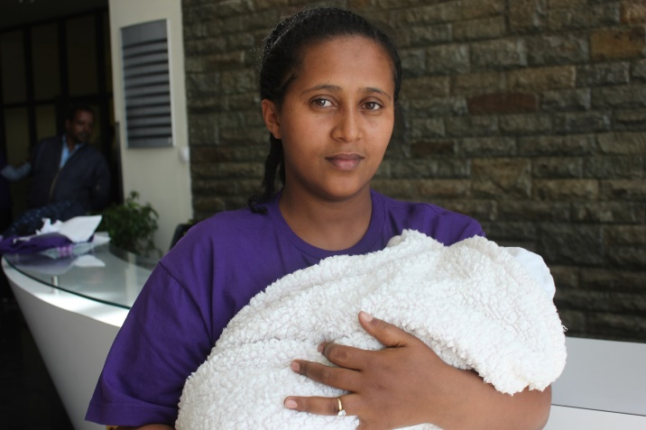
Martha Gebreyes, holding her preterm baby during the
WPD 2016 celebration on November17, 2016.
Photo Credit: Seifu Assegid, Save the Children in Ethiopia

The Story of Abeba Mengesha, 24, Born Premature and a Medical Doctor and a Lecturer at Adigrat University
Abeba Mengesha, 24 was born premature. She is now a medical doctor working as a lecturer at Adigrat University. Speaking at the event she said “I was told that I was born premature, , I weighted only 1000gms. Because of my condition, many people including my own mother were very worried that I may not survive. Some people even advised my mother not to waste too much time taking care of me In our community there is a deep rooted misconception about preterm babies. Most people think that premature babies will not survive and even if they do, they will not be successful in life. This is because they lack awareness. However, as history tells us, most famous people like Albert Einstein, the renowned Physicist, Isaac Newton and Charles Darwin naturalist were among those born premature and were very successful and some of the most gifted people who had ever lived in this world.” Concluding her testimony, Abeba called upon the audience to show the world their united voice and to reaffirm their commitment to support premature babies and their families:

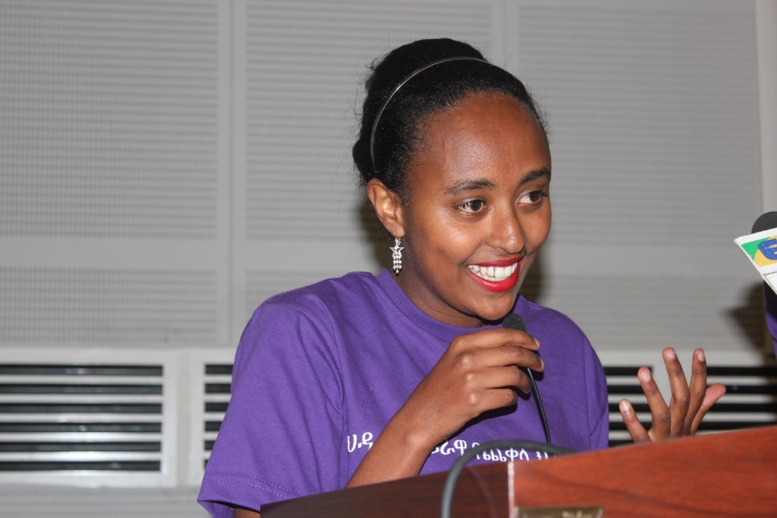
Abeba Mengesha, 24, was born premature.
She is now a medical doctor currently serving as a lecturer at the medical school of Adigrat Universty in Tigry Region.
Photo Credit: Seifu Assegid, Save the Children in Ethiopia

As part of its commitment to contribute to the reduction of neonatal morbidity and mortality, Save the Children International (SNL III, MCSP-NEGA and Every Last Child Campaign) provided various technical and material assistance to the FMOH which included: organizing a media roundtable; sponsoring radio spots on prematurity and newborn health related messages, availing T-shirts; flyers, 400 KMC wraps and sponsoring the WPD event.

MCSP-NEGA’s Staff Demonstrating the KMC Kit
to NICU focal persons at the event

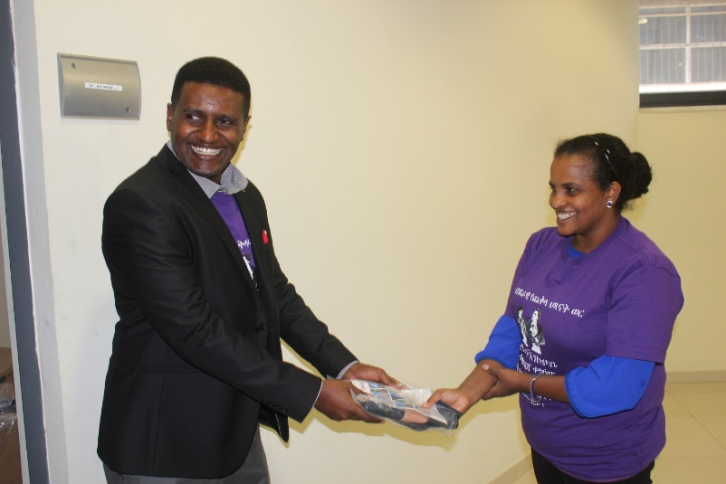
Dr Abreham from Ministry of Health handing over the KMC
Kit that Save the Children supplied to Seven Selected Hospitals

Media Roundtable
Save the Children in collaboration with Ministry of Health organized a media round table attended by more than 20 journalists from private and government owned printing, radio and TV media channels. The aim of the media roundtable was to raise awareness of media professionals on the importance of effective communication to bring the desired change on the communities’ attitude and knowledge practice towards newborn care and child health. It’s also aimed at addressing the misconception associated with pre-term babies. During the media round table an overview of the newborn and child health care in Ethiopia was briefly presented by an expert from Ministry of Health followed by a thorough discussion on the topic.

